DC-1 Machine Pentest Proof of Concept (PoC)

1. Target Identification & Initial Scanning
● Step: Use netdiscover or a similar tool to find the target's IP address on the local network,
followed by an aggressive Nmap scan to identify open ports and services.
● Action: Conducted an Nmap scan: nmap -sC -sV -T4 192.168.147.135.
● Discovery: Identified the target at 192.168.147.135 with ports 22 (SSH), 80 (HTTP), and
111 (RPC) open.

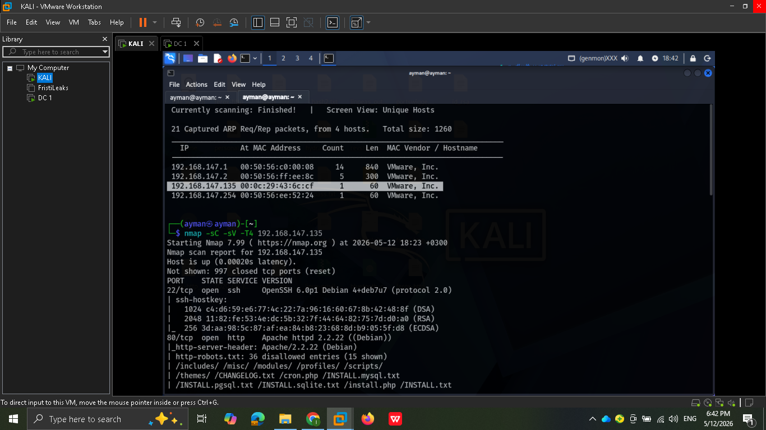
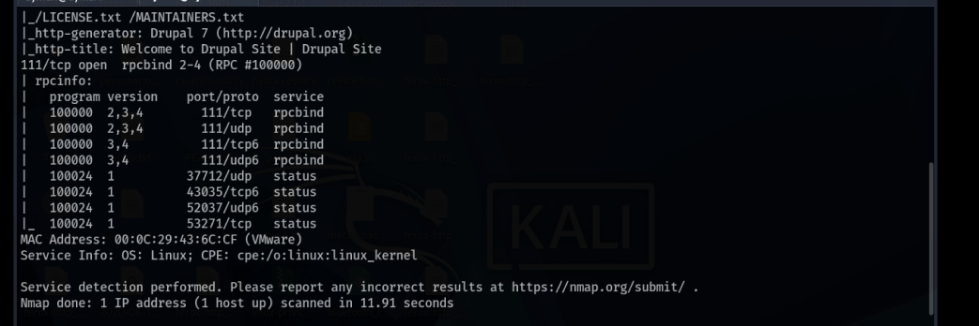

- Service Enumeration & Vulnerability Research

● Step: Search for known exploits for the identified services.
● Action: Used searchsploit to research vulnerabilities for rpcbind, Apache 2.2.22, and
OpenSSH 6.0p1.
● Step: Identify the CMS running on the web server.
● Observation: Used the Wappalyzer extension to confirm the site is running Drupal 7,
leading to the identification of the Drupalgeddon2 exploit as a potential attack vector.
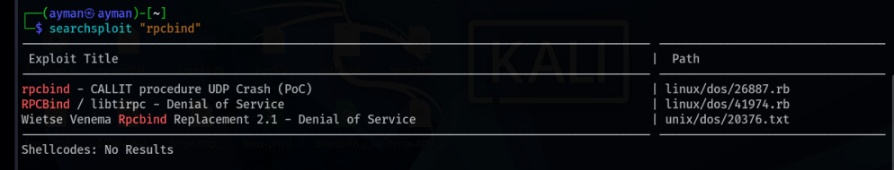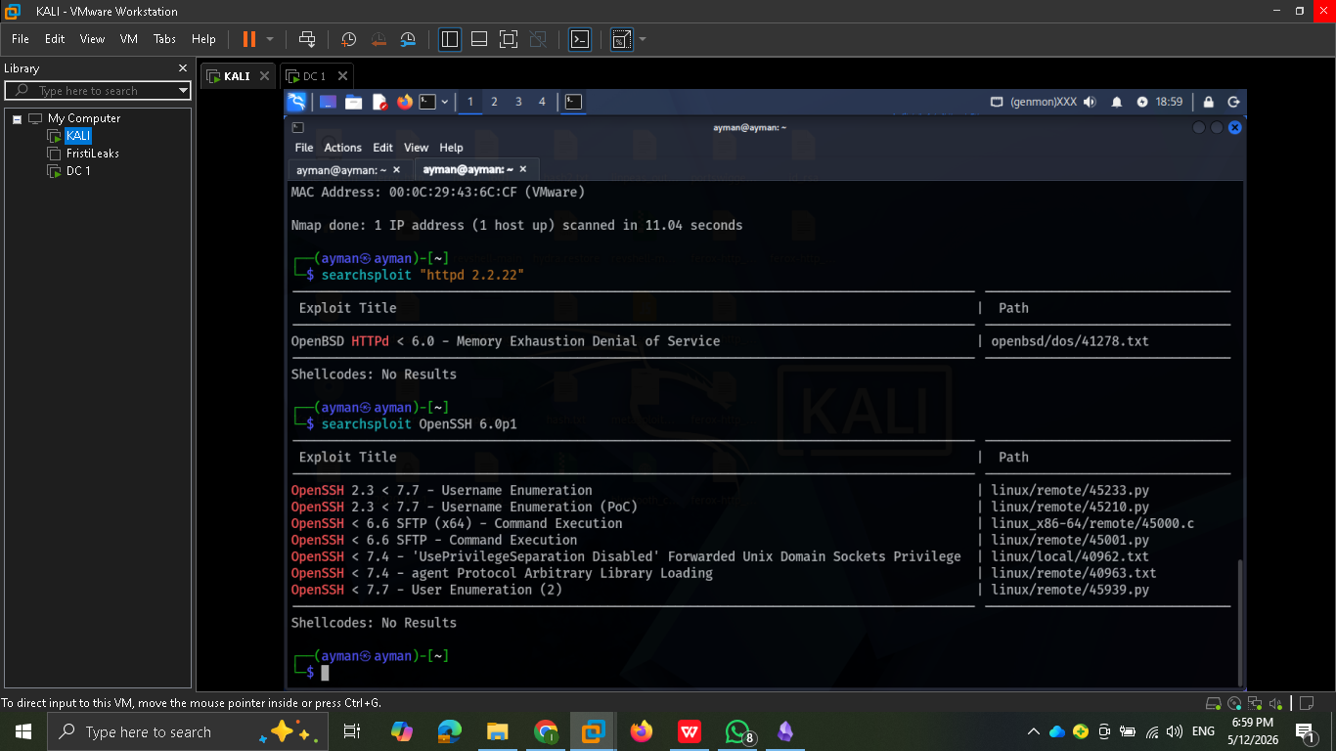
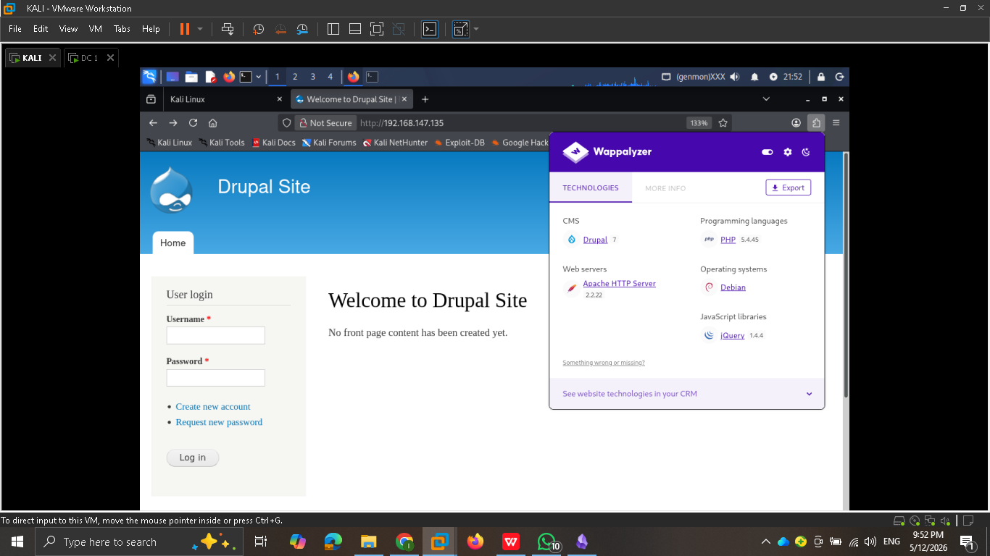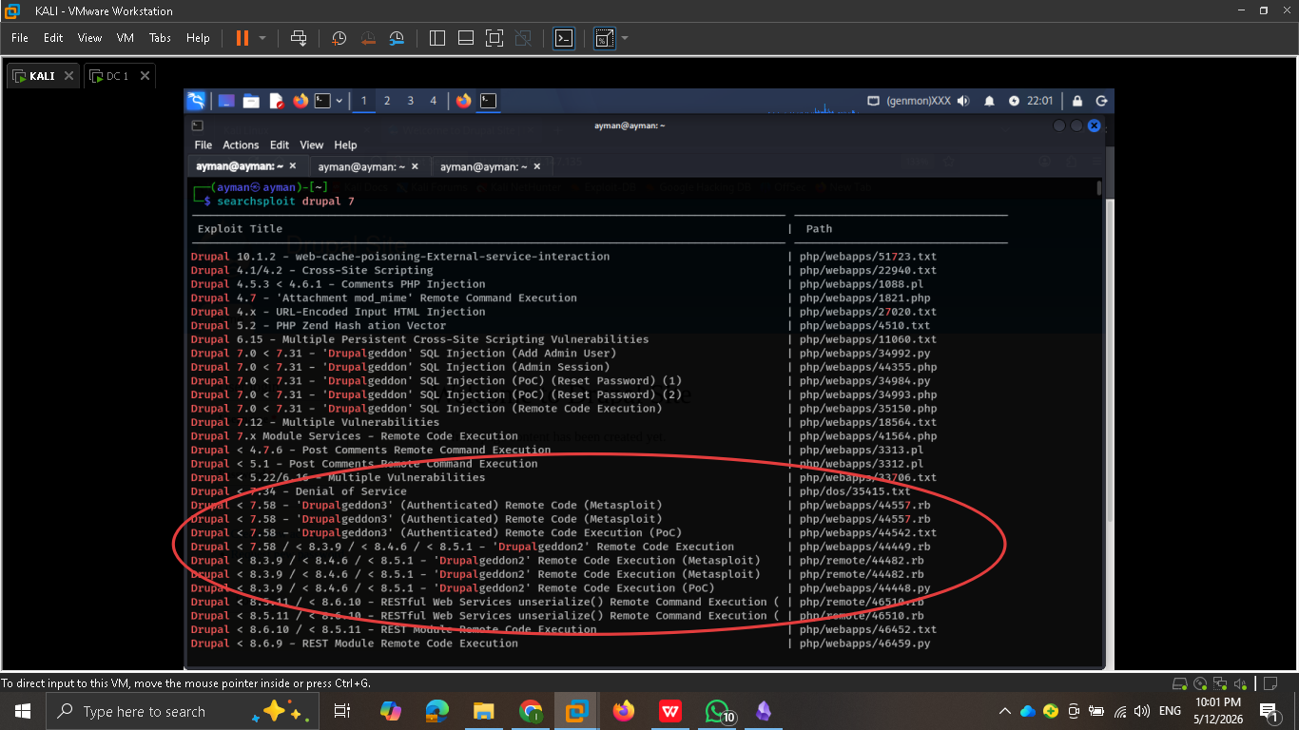

- Gaining Initial Access

● Step: Use the Metasploit Framework to exploit the Drupal vulnerability.
● Action: Selected the exploit/unix/webapp/drupal_drupalgeddon2 module and configured it
with the target (RHOSTS) and attacker (LHOST) IP addresses.
● Result: Successfully executed the exploit and established a Meterpreter session.

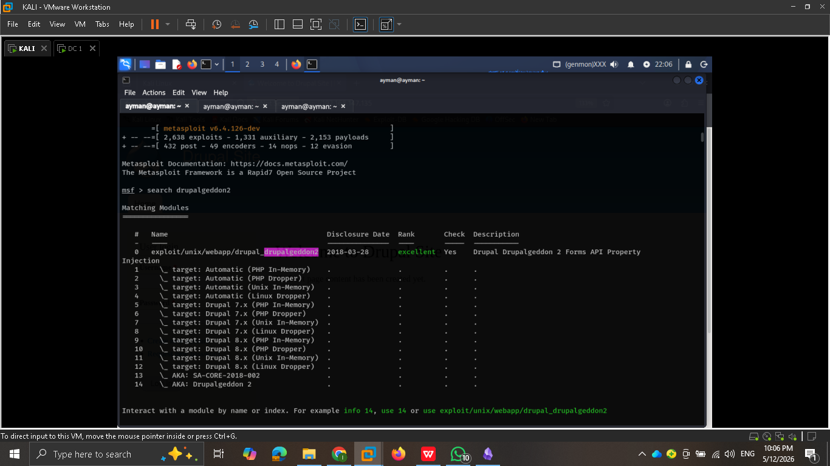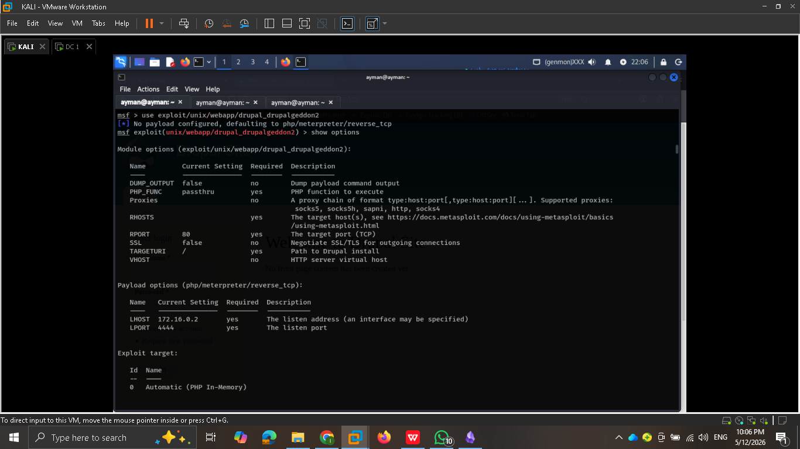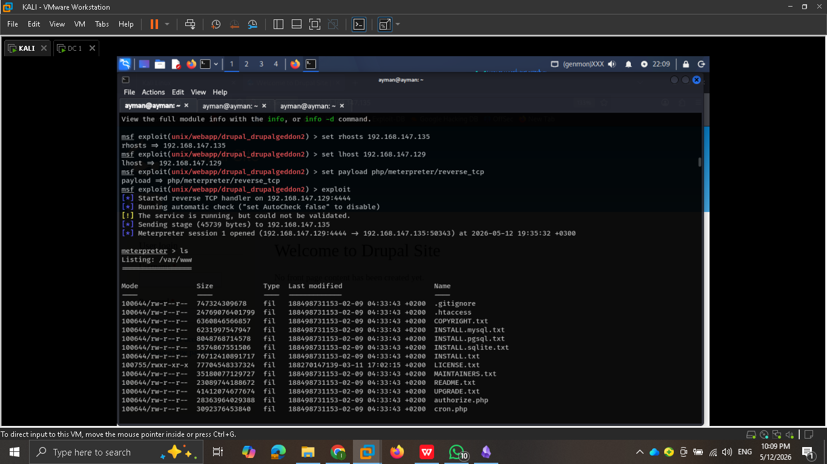

- Post-Exploitation & Data Discovery

● Step: Explore the file system for sensitive information and flags.
● Action: Discovered flag1.txt in the web root, which hints at checking the CMS
configuration file.
● Action: Navigated to /sites/default/ and accessed settings.php to find Flag 2 and
database credentials (dbuser / R0ck3t).

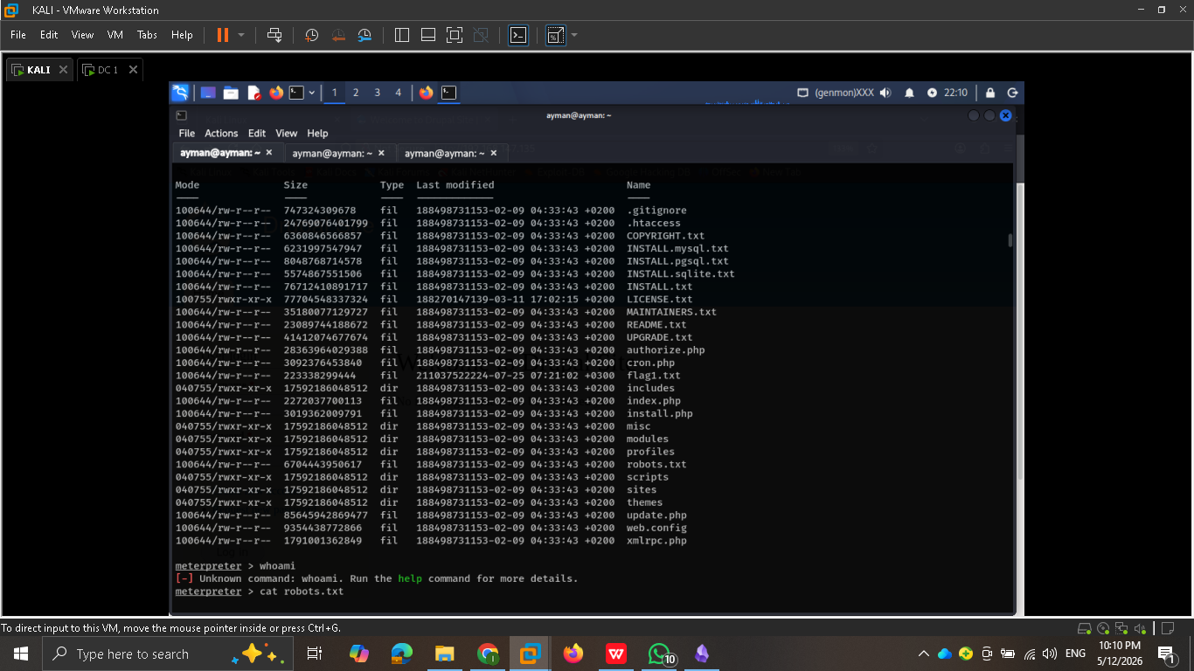
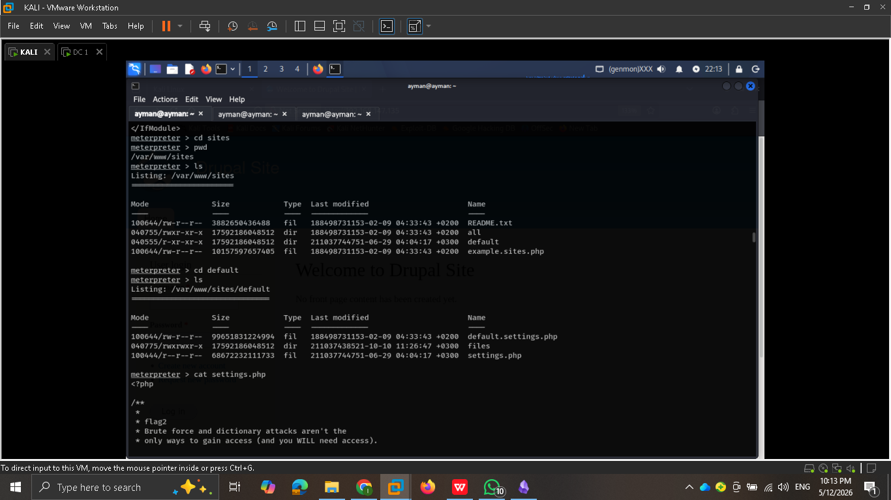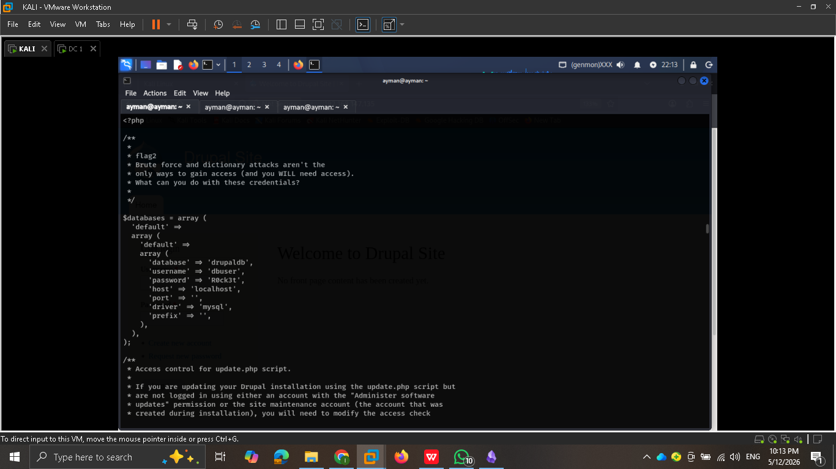

5. Database Interaction & Credential Modification

● Step: Access the back-end database to retrieve user information.
● Action: Spawned a TTY shell and logged into MySQL to extract usernames (admin,Fred) and their password hashes from the users table.
● Step: Gain administrative access to the Drupal site.
● Action: Used the drush utility to reset the admin password to "newpassword".
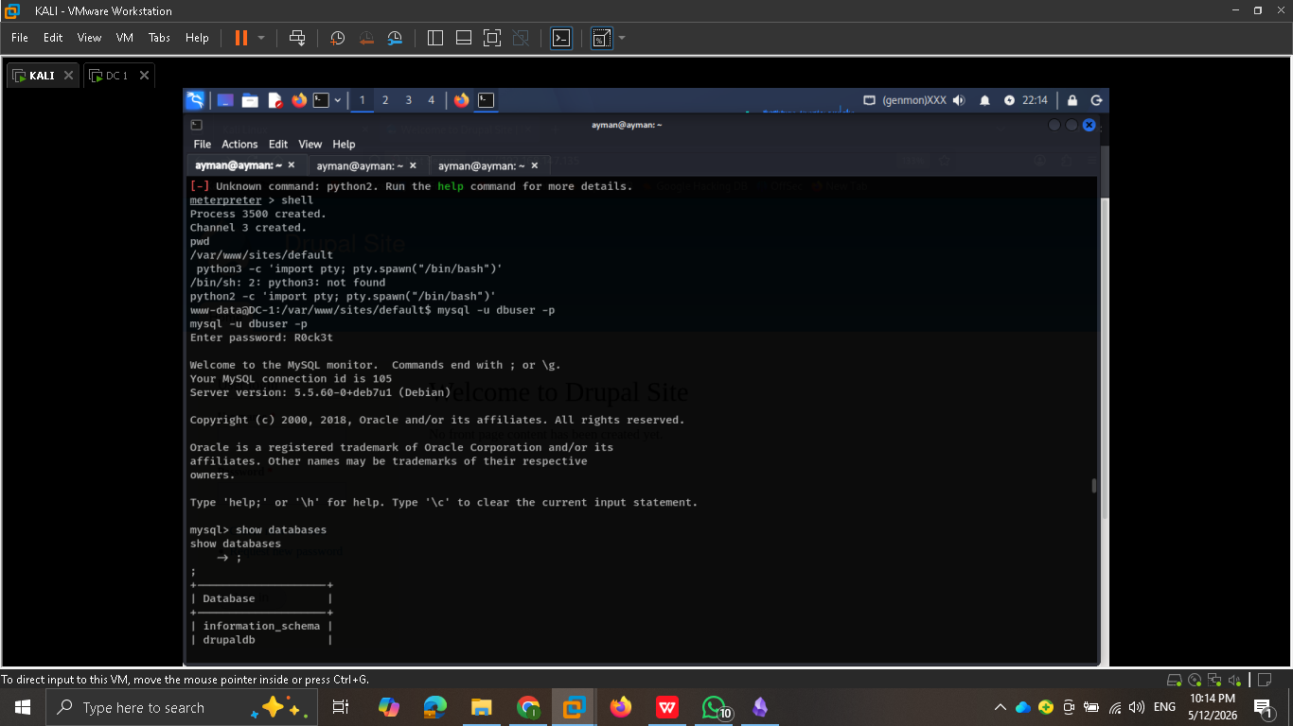
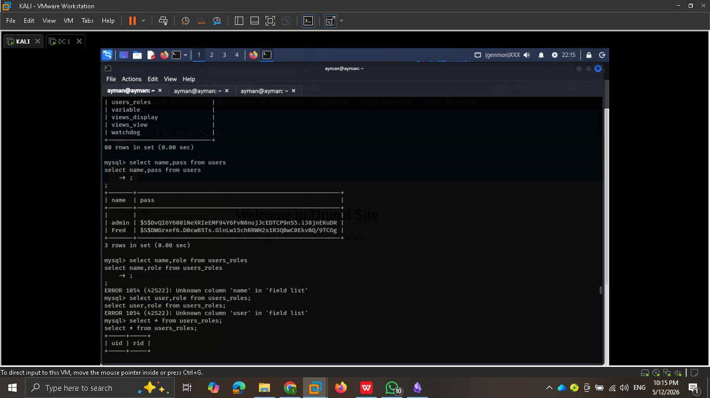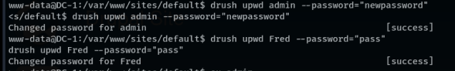

- System Enumeration

● Step: Search for further flags in the home directories.
● Action: Found flag4.txt in /home/flag4/, which hints that the final flag is in the root
directory but requires higher privileges.
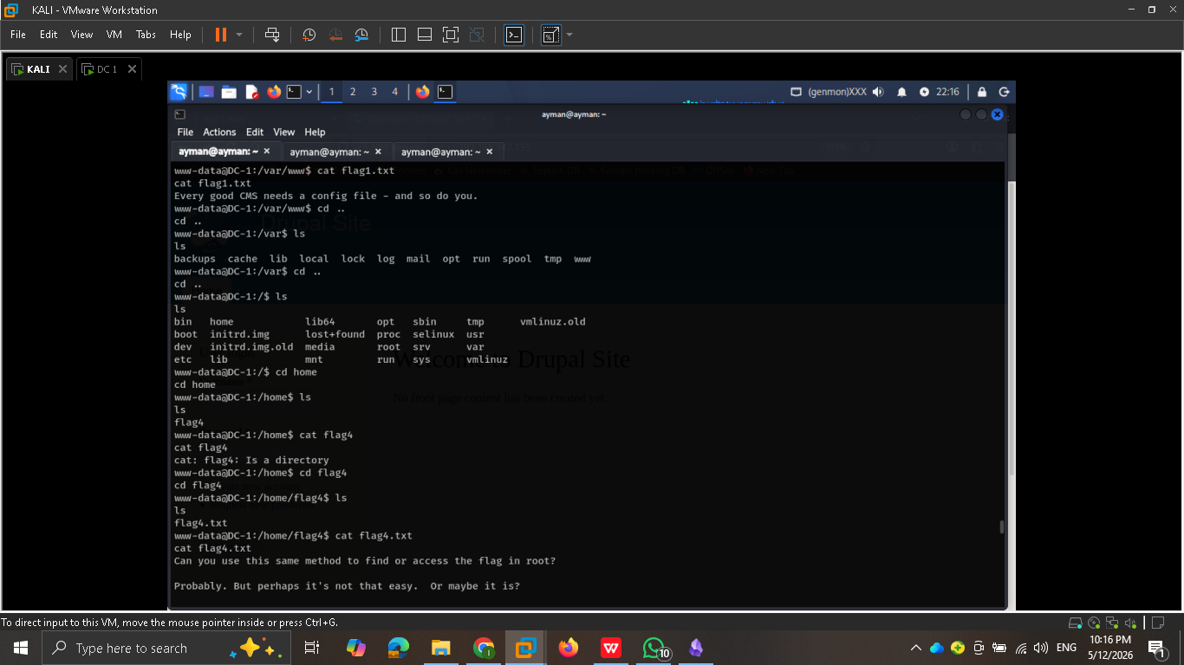

7. Privilege Escalation to Root

● Step: Identify a privilege escalation vector by searching for SUID binaries.
● Action: Ran find / -perm -4000 -type f 2>/dev/null and discovered that the /usr/bin/find
binary has SUID permissions.
● Action: Leveraged the SUID find binary to execute a root shell: find . -exec /bin/bash -p \;.
● Final Result: Successfully gained root access and captured the final flag
(thefinalflag.txt) in the /root directory
